Short Curriculum Vitae
JULITA SANSONI (phone: 0039.06.4959255- mail: julita.sansoni @uniroma1.it)
Main interests: Nursing discipline and professional development
Nursing research Family Nursing and elderly
Position: Associate Professor at University “La Sapienza” Roma
Education: University Advanced Nursing education (DAI)
Doctor in Pedagogy (Dr), Post doctor education in Adult education-1 e 2
Head Nurse Abilitation, Neurology and Neurosurgery specialization, Registred Nurse
Clinical experience in cardiology, psychiatry, neurology, neurosurgery, intensive care
On going doctoral studies (PhD) in Nursing Science Università di Tampere (Finlandia)
- Vicedirector and coordinator of University Advanced Nursing education – DAI University “La Sapienza” of Roma
- Head of the Nursing Area of the Public Health Department of University “La Sapienza” Roma and responsible for second level Nursing Degree
- Faculty in basic and post basic Nursing education
- Faculty in Medicine Degree courses
- Director first Level Masters in: Family Nursing, Health and Research of University “La Sapienza” (60 Credits), Data and Disaster Management, Forensic Nursing (2 level) and Nursing Research.
- Head of Nursing Research Group at “Sapienza” University
- National Evaluator of Continuing education courses (National system for Health professionals Continuing education)
- Expert in the National Commission for Health professions University entrance selection at the Research and Education Ministry
- Expert in Council of Europe Error in Medicine Group
- Has lead National and International continuing education courses and has been consultant in nursing project.
- Responsible for European Public Health project in Italy
- Collaboration with: Loyola University (Chicago and Roma), Griffith University (Australia), Tampere Universiy (Finlandia)
- Visiting Professor (2 months) at the Nursing Faculty Griffith University (Australia)
- Italian coordinator for FIPSE programme (e-learning education)
- Has represented Italian nurses in: European Nursing Researchers Working Group (WENR), European Quality Assurance Group (EURO Quan)
- Represents Italian nurses in: Permanent Committee of European Nurses (EFN)
- Member of the Board of ICN (International Council of Nurses)
- Author of different articles and publications (105 article, 23 editorials, 5 books or chapters in books, 5 monographies, 200 scientific presentations in National and International Conferences, 14 posters)
- Director of refered Journal Professioni Infermieristiche
- Overseas Adviser Nursing Management Journal (Blackwell ) and Conemporay nurse

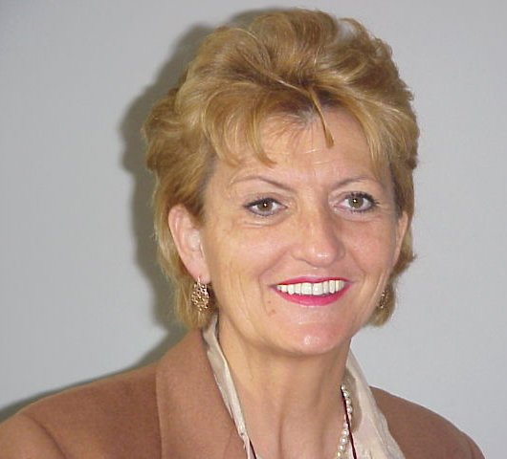
Julita Sansoni

- The involvement of professor Sansoni for the development of nursing science and discipline, is constant and her engagement has been quite significant in the Country. She is propelling and sustaining the nursing development. through education and political involvement
Her main efforts have been concerning:
- In the 80 ‘s has developed a new nursing specialization (neurology and neurosurgery) for Italian nurses
- In the 90 ‘s has significantly contributed to start the general Nursing education at University level
- In fall 2004 the first Master degree on Family and Health for Nurses will start under her direction
- She is a referral person for the profession in the Country. Her advices are requested at Ministry level and from the professionals.
- She has been the first nurse to get the academic professorship chair at the University in Italy
- Her research and engagements are particularly related to care giving and Alzheimer disease and grief process.

